SELECT count(tblcadets.CadetID),tblpeople.PersonID, tblpeople.PersonFN,tblpeople.PersonLN FROM tblpeople JOIN tblcadets ON tblcadets.fkPersonID =tblpeople.PersonID GROUP BY tblpeople.PersonID

ORDER BY count(tblcadets.CadetID) DESC

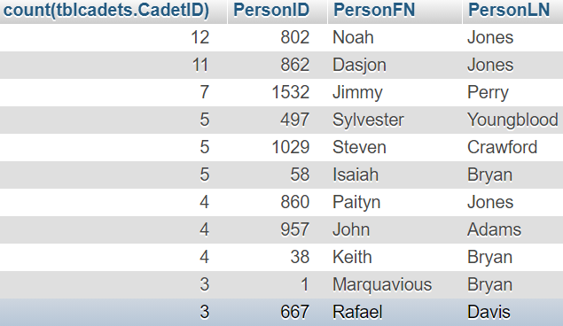

2) **show person’s id, name and medications**

SELECT tblpeople.PersonID,tblpeople.PersonFN,tblpeople.PersonLN, tblmeds.*

FROM tblmeds

JOIN tblclassdetails on tblclassdetails.ClassDetailID=tblmeds.fkClassDetailID

JOIN tblcadets on tblclassdetails.fkCadetID=tblcadets.CadetID

JOIN tblpeople on tblpeople.PersonID=tblcadets.fkPersonID

ORDER BY tblpeople.PersonLN

